
Data Security Envisioning Workshop
07-Module Delivery Guide-Windows Endpoints
v8.5 - January 2026

Contents
Disclaimer 3
Version history 4
We look forward to your feedback! 4
1 Introduction 5
1.1 Objectives 5
1.2 Delivery guidance 6
1.3 Scoping 6
1.4 Estimated partner effort 7
1.5 Tools and services used 7
1.5.1 Data Loss Prevention for Endpoints 7
1.6 Endpoint requirements 8
1.7 Tools and services used 8
2 Activity details 9
2.1 Step 1 - Kick-off meeting 9
2.2 Step 2 - Acquire and assign licenses. 10
2.3 Step 3 - Setup and configuration 10
2.3.1 Configuring Data Loss Prevention for Endpoints audit settings 11
2.3.2 Onboarding devices 12
2.3.3 Turn on device monitoring 15
2.3.4 Data Loss Prevention for Endpoints – Out-of-box Sensitive Info Types 15
2.3.5 Data Loss Prevention for Endpoints – Custom Sensitive Info Types 18
2.4 Step 4 - Analyze the findings 21
2.5 Step 6 - Decommission 27

Disclaimer
The Data Security Envisioning Workshop provides a summary of an organization’s data protection and compliance stature and recommendations to improve data protection and compliance.
The information, results, and scoring provided through the Data Security Envisioning Workshop are recommendations and provided for general informational purposes only. They do not constitute legal advice, certifications, or guarantees regarding regulatory compliance; it is up to each organization to evaluate the effectiveness of these recommendations in their respective regulatory environment prior to implementation. Organizations should consult with their own legal professionals to determine how standards or regulations apply to their organization and how to best ensure compliance.
We hope the Data Security Envisioning Workshop helps identify technologies and additional steps that organizations can implement to simplify their compliance efforts.
MICROSOFT MAKES NO WARRANTIES, EXPRESS, IMPLIED, OR STATUTORY, AS TO THE INFORMATION IN THIS Data Security Envisioning Workshop. Microsoft disclaims any conditions, express or implied, or other terms that use of the Microsoft products or services will ensure the organization’s compliance with regulations or standards. This Data Security Envisioning Workshop Toolkit is provided “as-is.” Information and recommendations expressed in the Data Security Envisioning Workshop Toolkit may change without notice.
The Data Security Envisioning Workshop Toolkit does not provide the user with any legal rights to any intellectual property in any Microsoft product or service. Use of the tool is for internal, reference purposes only; however, Microsoft partners may distribute the Data Security Envisioning Workshop Toolkit to their customers for such customers’ internal, reference purposes only. Any distribution of the Data Security Envisioning Workshop Toolkit by a Microsoft partner to its customers must include terms consistent with those set forth in this disclaimer.
© 2026 Microsoft. All rights reserved.

Version history
Version | Author | Changes | Date
3.0 | François van Hemert | First published release | January 2021
3.1 | François van Hemert | Minor textual updates | February 2021
4.0 | François van Hemert | Workshop split, update to align with new narrative, rebranding, updates to guidance and organized around data repositories. | June 2021
4.1 | François van Hemert | Update illustration for Compliance Manager Premium Assessments. | October 2021
4.2 | François van Hemert | Purview branding update, step-by-step guidance update to align with changes M365. | July 2022
4.2.2 | François van Hemert | Update to align with current product features and functionality (evergreen). | January 2023
6.0 | François van Hemert | Workshop merge, align with FY24 solution play, focus on Data Security. | August 2023
6.5 | François van Hemert | Update step guidance, align with FY25 solution play | July 2024
6.6 | François van Hemert | Update to align with the new Microsoft Purview Portal | October 2024
7.0 | François van Hemert | Updated for additional module on Generative AI | January 2025
7.1 | François van Hemert | Version number update, no further changes | May 2025
8.0 | François van Hemert | Update to align with current product features and functionality (evergreen), update name, update branding. | July 2025
8.5 | François van Hemert | Update to align with current product features and functionality (evergreen) | January 2026


We look forward to your feedback!
Thank you for your continued trust and partnership. The resources within this toolkit will be iteratively improved upon based on product releases as well as direct feedback from delivered engagements. We encourage you to provide feedback to help us improve our products and toolkits.
Please share your feedback and questions via our Engagement feedback form that can be found at: https://aka.ms/SCIEngagementsFeedback.

Introduction
This document contains delivery guidance for the optional Windows Endpoints activity that will extend the Automated Discovery Process with monitoring of actions that are being undertaken on sensitive items present on Windows Endpoints.
The outcome and findings of this activity will be merged into the overall findings and recommendations that will be presented at the end of the Data Security Envisioning Workshop.

Objectives
The objectives for this activity are:
- Identify risky activity and privacy and regulatory risks on Windows 11 devices.
Once devices are onboarded to the Microsoft Purview Data Loss Prevention for Endpoints solution, the information about what users are doing with sensitive items is made visible in the Activity Explorer. This will help identify risky or unwanted behavior that may impose data security risks to the organization.
- Understand how to mitigate identified data security risks.
Help customers to better understand, prioritize, and mitigate the data security risks that were identified by Data Loss Prevention for Endpoints.
- Provide recommendations and define next steps.
Recommendations and next steps based on the findings from this activity will be rolled up into the overall Data Security Envisioning Workshop close-out presentation.

Delivery guidance
This document is an integral part of the overall delivery guidance for the Data Security Envisioning Workshop. When delivering the Data Security Check, follow the guidance provided in the <00-Master Delivery Guide> and when instructed, engage in the supplemental activities outlined in this guide.
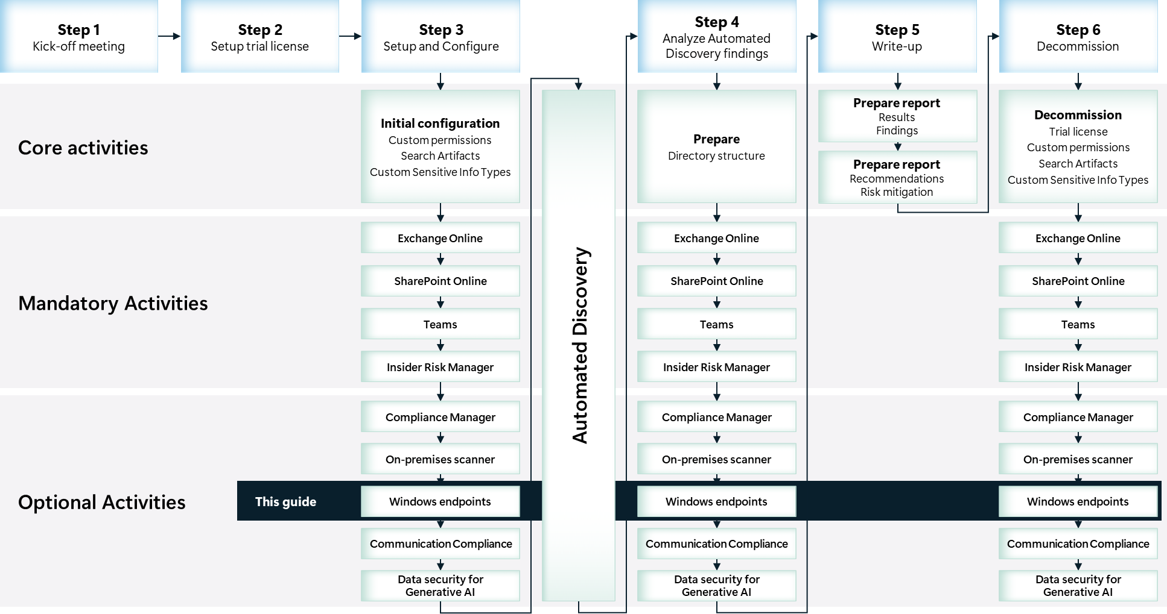

Scoping

In scope
The scope for this activity includes:
- Install and configure Data Loss Prevention for Endpoints.
- Onboard Windows 11 devices to Data Loss Prevention for Endpoints.
- Identify risky or unwanted behavior with data containing sensitive information that may impose privacy and regulatory risks to the organization.

Estimated partner effort
The table below provides a high-level estimate of the additional partner effort for the activities described in this guide. The numbers provided are to be considered indicative and can change as a result of customization of the delivery schedule and the individual activities.
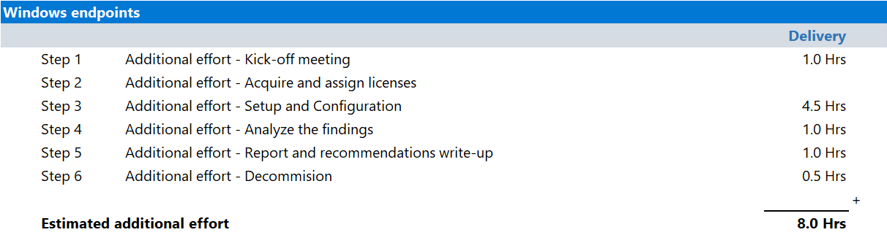

Tools and services used
The Data Security Check Automated Discovery process leverages Data Loss Prevention for Endpoints to discover and report on data security risks on Windows 11 endpoints.

Data Loss Prevention for Endpoints

Overview
Data Loss Prevention for Endpoints extends the monitoring and protection capabilities of Microsoft Purview Data Loss Prevention to data on Windows 11 devices. Once devices are onboarded into Microsoft Purview solutions, the information about what users are doing with sensitive items is made visible in Activity Explorer and you can enforce protective actions on those items via Data Loss Prevention policies.

Product information
- For detailed information refer to Learn about Endpoint data loss prevention.

Functionality used by the Data Security Check.
- Data Security Check leverages Data Loss Prevention for Endpoints to identify risky behavior by users working with sensitive data of their workstations or laptops.

Endpoint requirements
Data Loss Prevention for Endpoints depends on services offered by Windows 11. The endpoints targeted for the installation Data Loss Prevention for Endpoints must meet all of the following requirements:
 Important
The list of pre-requisites is frequently updated, so before engaging on this activity, check the information outlined in Onboard Windows devices into Microsoft 365 overview.

- Verify the devices that are targeted for onboarding meet the minimum requirements as outlined on Prepare your Windows devices

Tools and services used
The Data Security Check Automated Discovery process leverages Data Loss Prevention for Endpoints to discover and report on data security risks originating from client endpoints.

Overview
Data Loss Prevention for Endpoints builds on labeling and classification capabilities provided by Microsoft Purview Information Protection. It extends the activity monitoring and protection capabilities of DLP to sensitive items that are physically stored on devices running Windows 10/11, macOS (the three latest released major versions) and a subset of Windows server versions.
Once devices are onboarded into the Microsoft Purview solutions, the information about what users are doing with sensitive items is made visible in activity explorer. You can then enforce protective actions on those items via DLP policies , It is also integrated in Microsoft Defender for Endpoint to help prioritize and streamline incident response based on additional factors.

Product information
For more information on Data Loss Prevention for Endpoints, refer to:
- Learn about Endpoint data loss prevention
- Endpoint Data Loss Prevention (DLP) | What it is and how to set it up in Microsoft 365

Functionality used by the Data Security Check
The Data Security Check will leverage Data Loss Prevention for Endpoints to:
- Identify risky activity and data security risks on Windows 11 devices.

Activity details

Step 1 - Kick-off meeting

Guidance
Follow the guidance for the Kick-off meeting provided in the <00-Master Delivery Guide> and add an additional section to the meeting(s) to discuss:
- The additional functionality that Data Loss Prevention for Endpoints will add to the Automated Discovery process.
- The pre-requisites the endpoints have to meet. Pay special attention to:
  - Windows 11 requirements, what are the operating system build levels and installed updates currently in use by the organization?
  - Are the devices Microsoft Entra joined, Microsoft Entra Hybrid joined, or Microsoft Entra registered?
  - On-boarding of devices, are devices enrolled into Microsoft Defender for Endpoint or is a different enrollment method needed?
  - What deployment options are available, does the organization use Group Policies, Microsoft Endpoint Configuration Manager, or Mobile Device Management?
  - Third-party antivirus, is the organization using third-party antivirus solutions or do they rely on Microsoft Defender Antivirus?
  - Third-party Endpoint Detection and Response solutions, is the organization using a third-party EDR solution?
- Which endpoints will be enabled to use Data Loss Prevention for Endpoints?
The <40-Pre-engagement and Kickoff deck> contains optional slides with speaker notes that can be used to facilitate the discussion and document the outcome.

Supporting materials
- <40-Pre-engagement and Kickoff deck>
Note
The <40-Pre-engagement and Kickoff deck> is used for both the Pre-engagement meeting and the Kick-off meeting. Instructions on how to update the slides are included as hidden slides in the deck.

Pre-requisites
- The activities and guidance described in this step complement Step 1 - Kick-off meeting as described in the <00-Master Delivery Guide>. The activities should be merged and delivered as one.

Next step
- Return to the <00-Master Delivery Guide> and continue the guidance provided in Step 1 - Kick-off meeting.

Step 2 - Acquire and assign licenses.
The required product licenses for this activity are included in the overall Data Security Check trial license that was deployed in Step 2 - Acquire and assign licenses of the 00-Master Delivery Guide. No additional (trial) licenses are required.
 Important
To access and use Data Loss Prevention for Endpoints functionality, all users participating in this activity must be assigned a license from the overall Data Security Check trial license.

Next step
- Return to the <00-Master Delivery Guide> and continue the guidance provided in Step 2 - Acquire and assign licenses.

Step 3 - Setup and configuration

Guidance
This section describes the steps required to install, configure, and run Data Loss Prevention for Endpoints as part of the Data Security Check.

Background reading
For more information refer to:
- Get started with Endpoint Data Loss Prevention
- Configure proxy on the Windows 10 or Windows 11 device
- Use Endpoint data loss prevention.

Pre-requisites
Prior to starting the activities in this step, the following mandatory Data Security Check activities as described in <00-Master Delivery Guide> should be completed:
- Step 1 - Kick-off meeting
- Step 2 - Acquire and assign licenses
- Step 3 - Setup and configuration

 Important
Data Loss Prevention for Endpoints relies on Sensitive Info Types to identify privacy and regulatory risks. Before starting this activity, the instructions outlined in Step 3 - Setup and configuration in the <00-Master Delivery Guide> should be completed successfully. (i.e. all customer specific sensitive information types configured and available).

Configuring Data Loss Prevention for Endpoints audit settings

Guidance
For the Data Security Check, Data Loss Prevention for Endpoints will be configured to:
- Monitor all file activity for Office, PDF, and CSV files on all enrolled Windows 11 endpoints.
- Check all files for the presence of:
- All Out-of-box Sensitive Info Types available on the on the customer’s tenant.
- All Custom Sensitive Info Types configured through Data classification on the customer’s tenant.
If required, Data Loss Prevention for Endpoints can be configured to use policies that allow for:
- Only monitoring devices that are explicitly included in the policy.
- Only check for Sensitive Info Types explicitly included in the policy.
Enabling the use of Data Loss Prevention policies can be configured through the Microsoft Purview portal and is considered out-of-scope for this activity.

Objective(s)
- Verify and configure audit setting for Data Loss Prevention for Endpoints.

Background reading
- Use Endpoint data loss prevention
- Configure endpoint data loss prevention settings

Instructions
- Browse to the Microsoft Purview portal at https://purview.microsoft.com/ and log in with Tenant Admin credentials or a user account that is a member of your Data Security Check team and has been assigned the appropriate permissions.
- In the navigation bar on the left side, click on Settings.
- On the Settings solution card, click on Data Loss Prevention.
- On the Data Loss Prevention settings page, click on Endpoint DLP settings.
- On the Endpoint DLP settings page, expand Always audit file activity for devices.
- Verify Always audit file activity for devices is enabled.
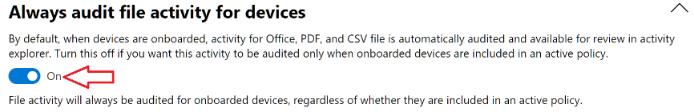
- On the Endpoint DLP settings page, expand Network share coverage and exclusions.
- Enable Network share coverage and exclusions.
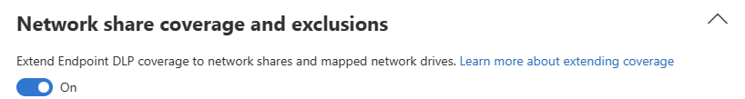
- On the Endpoint DLP settings page, expand Advanced classification scanning and protection
- Enable Advanced classification scanning and protection
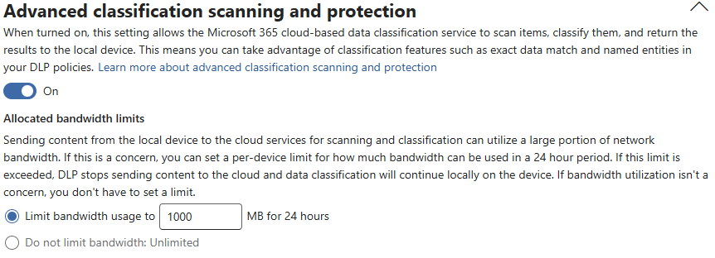

Onboarding devices

Guidance
Endpoint monitoring requires onboarding devices through the Microsoft Purview portal.
Devices that have already been onboarded to Microsoft Defender for Endpoint will automatically appear in the managed devices list and do not require additional onboarding. To onboard devices that haven't been onboarded yet, an onboarding script needs to be downloaded and deployed to these devices.
The illustration below provides a high-level overview of the different methods of onboarding devices to Data Loss Prevention for Endpoints.
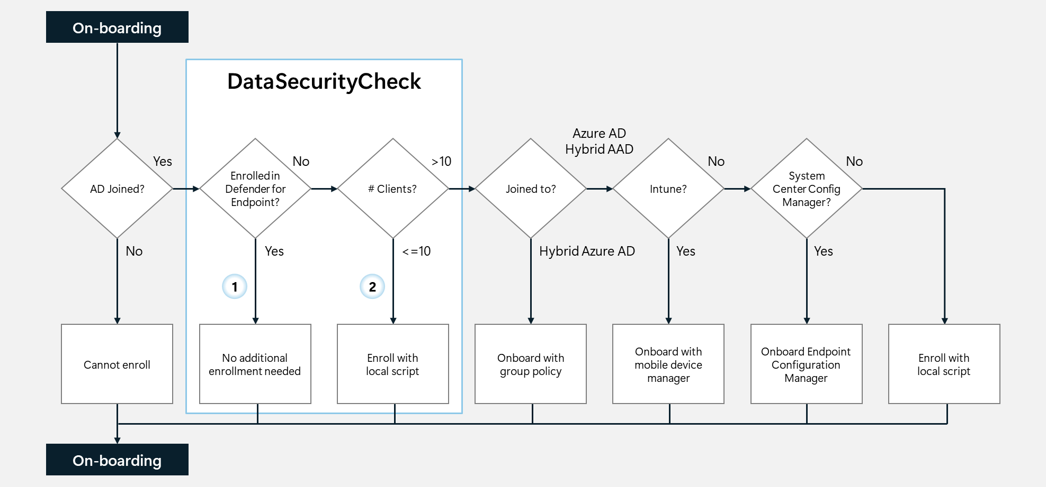
This guide will provide onboarding instructions for:
Option : Endpoints already enrolled in Microsoft Defender for Endpoint.
Option : Endpoints that will be enrolled through the execution of a local script.
For all other onboarding options, refer to Defender for Endpoint onboarding Windows client devices.

Objective(s)
- Onboard the endpoints that will participate in the Data Security Check onto Data Loss Prevention for Endpoints.

Background reading
- Windows 10 and Windows 11 Onboarding procedures
- Onboard Windows 10 and Windows 11 devices using a local script

Instructions – Option – Verify endpoint is enrolled in Microsoft Purview portal
Endpoints that have onboarded to Microsoft Defender for Endpoint will appear in the managed devices list. These devices are already reporting in, and no further onboarding action is required.
To understand and verify which devices are onboarded, follow the steps outlined below:
- Browse to the Microsoft Purview portal at https://purview.microsoft.com/ and log in with Tenant Admin credentials or a user account that is a member of your Data Security Check team and has been assigned the appropriate permissions.
- In the navigation bar on the left side, click on Settings.
- On the Settings card, expand Device onboarding
- Below Device onboarding, click on Devices.
- Verify the devices that will participate in the Data Security Check are listed on the devices overview.

Instructions – Option – onboarding Windows 11 devices using a local script
For customers not using Microsoft Defender for Endpoint or devices that have not (yet) been onboarded, the endpoint has to be onboarded before it can participate in the Data Security Check. This section will describe the steps to onboard a Windows 11 endpoint by executing a local script.
Note
Onboarding devices by using a local script is optimized for onboarding one to ten devices. For alternative onboarding methods, refer to Windows 10 and Windows 11 Onboarding procedures.

- Browse to the Microsoft Purview portal at https://purview.microsoft.com/ and log in with Tenant Admin credentials or a user account that is a member of your Data Security Check team and has been assigned the appropriate permissions.
- In the navigation bar on the left side, click on Settings.
- On the Settings card, expand Device onboarding
- Below Device onboarding, click on Onboarding.
- If device onboarding has not been enabled yet, click Turn on device onboarding.
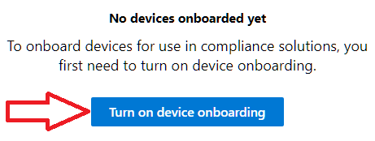
- On the Turn on device onboarding pop-up window, click OK.
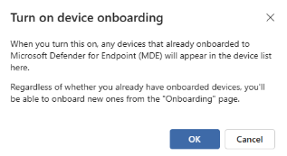

Note
Turning on device onboarding will take time; refresh the page to check progress.

- Below Select operating system to start onboarding process, select Windows 10.
- Below Deployment method, select Local script (for up to 10 machines).
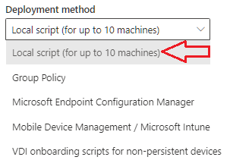
- Click on Download package. This will download the package as a zip file <DeviceComplianceOnboardingPackage.zip> to the default download folder.
- Copy the <DeviceComplianceOnboardingPackage.zip> file to the client workstation that has to be onboarded.
- Extract the contents of the configuration package <DeviceComplianceLocalOnboardingScript.cmd>to a location on the device that needs to be onboarded.
- Go to Start and type Cmd.
- Right click Command prompt and select Run as Administrator.
- Browse to the location of the script file.
- Run DeviceComplianceLocalOnboardingScript.cmd.
- Enter Y to confirm.
- Verify the script completed successfully
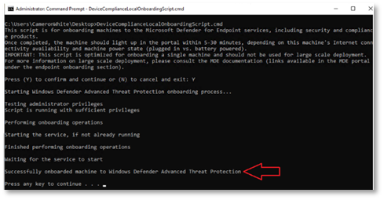
- Close the command prompt.
- Follow the instructions outlined above (Instructions – Option – Verify endpoint is enrolled in Microsoft Purview portal) and check if the device is listed in the Devices overview.

Note
It might take 5-30 min before a newly onboarded device is visible in the Devices overview.

Turn on device monitoring
To start monitoring activity from devices that have been onboarded to Data Loss Prevention for Endpoints, device monitoring has to be turned on.
- Browse to the Microsoft Purview portal at https://purview.microsoft.com/ and log in with Tenant Admin credentials or a user account that is a member of your Data Security Check team and has been assigned the appropriate permissions.
- In the navigation bar on the left side, click on Settings.
- On the Settings card, expand Device onboarding
- Below Device onboarding, click on Devices.
- On the Devices page, if not yet turned on, click on Turn on Windows device monitoring.
- Click Yes.

Data Loss Prevention for Endpoints – Out-of-box Sensitive Info Types

Guidance
This section describes the Steps to create a sample Data Loss Prevention policy that searches for U.S. financial data.
Note
Replace or update the data types used in this sample policy with data types that meet your customer’s requirements as defined in the Pre-engagement meeting or Kick-off meeting.

Objective(s)
- Configure the Automated Discovery process to search for Out-of-box Sensitive Info Types based on the selection made during the Pre-engagement meeting or Kick-off meeting.

Automated Discovery target locations
- Windows 11 endpoints enrolled in the Microsoft Purview portal.

Background reading
For more information refer to:
- Sensitive information type entity definitions
- Configure Data Loss Prevention (DLP) policies

Instructions - create a DLP policy for Out-of-box Sensitive Info Types
- Browse to the Microsoft Purview portal at https://purview.microsoft.com/ and log in with Tenant Admin credentials or a user account that is a member of your Data Security Check team and has been assigned the appropriate permissions.
- In the navigation bar on the left side, click on Solutions
- In the Solutions navigator, click on Data loss prevention.
- On the Data Loss Prevention solution card, click on Policies.
- On the Policies page, click + Create policy.
- On the Choose what type of data to protect page, select Enterprise applications & devices
- Click Next.
- On the Start with a template or create a custom policy page, select a policy template relevant to your customer.

Note
Policies have a strong dependency on the region the customer is operating in, if the customer is unfamiliar with local regulations, it is advised to select a generic template. For example for customers based in the United States of America, choose Privacy U.S. Personally Identifiable Information (PII) Data Enhanced and for customers located in the European Union, choose Privacy GDPR Enhanced

- Click Next.
- On the Name your DLP policy page, type DataSecurityCheck-DLP-OutOfBox-Devices as the name of the new policy and provide a meaningful Description.
- Click Next.
- On the Assign admin units page, click Next.
- On the Choose locations to apply the policy pane, enable Devices and disable all other locations.
- Click Next.
- On the Define policy settings page, select Create or customize advanced DLP rules.
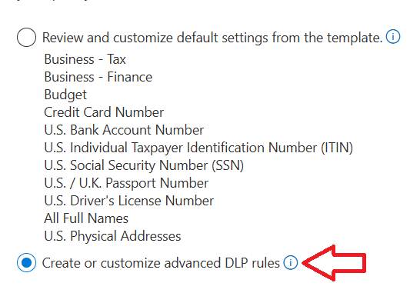
- Click Next.
- On the Customize advanced DLP rules page, expand Low volume of content detected…. by clicking on the arrow.
- Click on the Pencil to edit the policy.
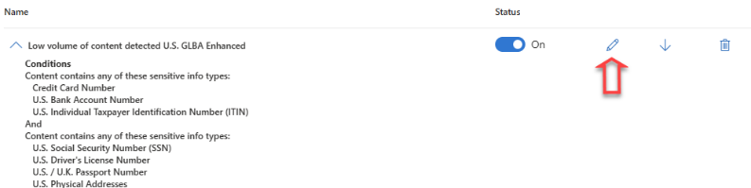

Instructions - Update the advanced policy settings
- On the Edit rule page, below Actions, click on Add an action.
- From the dropdown menu, select Audit or restrict activities on devices.
- Below File activities for all apps, select Apply restrictions to specific activity.
- Enable Copy to clipboard and verify the action is set to Audit only.
- Enable Copy to removable USB device and verify the action is set to Audit only.
- Enable Copy to a network share and verify the action is set to Audit only.
- Enable Print and verify the action is set to Audit only.
- Enable Copy or move using RDP and verify the action is set to Audit only.
 Important
Carefully check and verify if all actions are configured correctly. Failure to do so will impact the user experience.

- Below User notifications set the slider to Off to disable notifications to content owners and/or users.
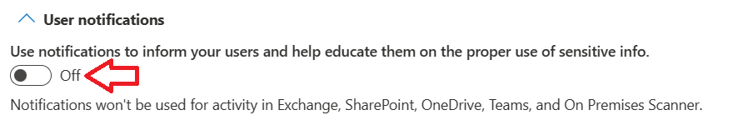
- Below Incident reports verify the slider is set to Off.
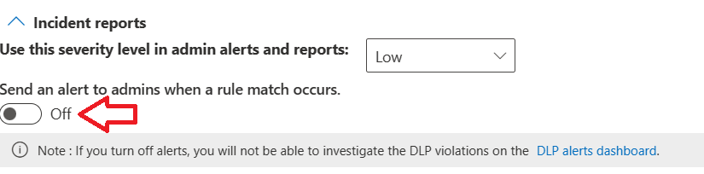
- Click Save.
- Repeat the Steps described above in Instructions - Update the advanced policy settings for High volume of content detected….
- Click Next.
- On the Policy mode page, select Turn the policy on immediately.
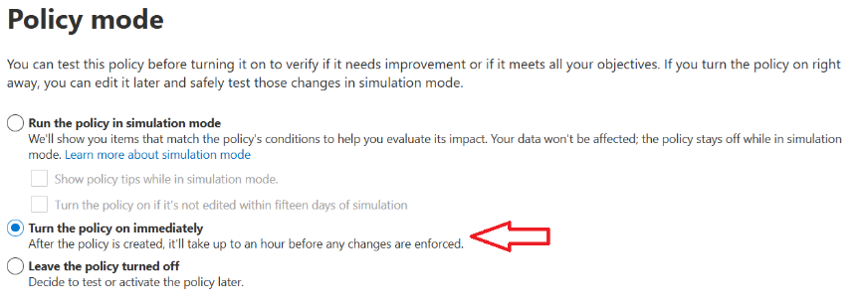
Note
It can take up to one hour for the new policy to go into effect.

- Click Next.
- Review your settings and then click Submit.
- On the New policy created page, click Done.

Data Loss Prevention for Endpoints – Custom Sensitive Info Types

Guidance
This section describes the steps to create a sample Data Loss Prevention policy to discover Custom Sensitive Info Types that were configured to match specific customer requirements. The policy will look for the custom information types previously configured in data that is in transit.

Objective(s)
- Configure the Automated Discovery to search for a customer-specific search term based on the selection made during the Pre-engagement meeting or Kick-off meeting.

Automated Discovery target locations
- Windows 11 endpoints enrolled in the Microsoft Purview portal.

Background reading
For more information refer to:
- Learn about sensitive information types.

Instructions - create a DLP policy for Custom Sensitive Info Types
- Browse to the Microsoft Purview portal at https://purview.microsoft.com/ and log in with Tenant Admin credentials or a user account that is a member of your Data Security Check team and has been assigned the appropriate permissions.
- In the navigation bar on the left side, click on Solutions
- In the Solutions navigator, click on Data loss prevention.
- On the Data Loss Prevention solution card, click on Policies.
- On the Policies page, click + Create policy.
- On the Choose what type of data to protect page, select Data stored in connected sources.
- Click Next.
- On the Start with a template or create a custom policy page, below Categories click on Custom
- Below Regulations, click on Custom policy.
- Click Next.
- Type DataSecurityCheck-DLP-Custom-Devices as the name of the new policy and provide a meaningful Description.
- Click Next.
- On the Assign admin units page, click Next.
- On the Choose locations to apply the policy pane, enable Devices and disable all other locations.
- Click Next.
- On the Define policy settings page, verify Create or customize advanced DLP rules is selected.
- Click Next.
- On the Customize advanced DLP rules page, click +Create rule.
- Below Name enter DataSecurityCheck-DLP-CustomRule-Devices and provide a meaningful Description.
- Below Conditions, click +Add condition and select Content contains from the drop-down list.
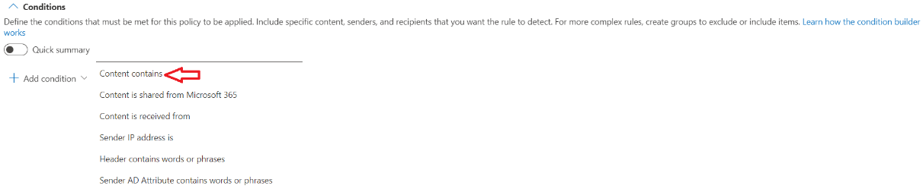
- Below Group operator, verify Any of these is selected.
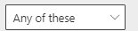
- Below Content contains, click Add and select Sensitive Info Types from the drop-down list.
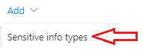
- On the Sensitive info types page, select all Custom Sensitive Info Types identified by you and your customer during the Pre-engagement meeting or Kick-off meeting.
Note
The Custom Sensitive Info Types can be easily identified by searching on the <Publisher> name or by searching for <DataSecurityCheck->.
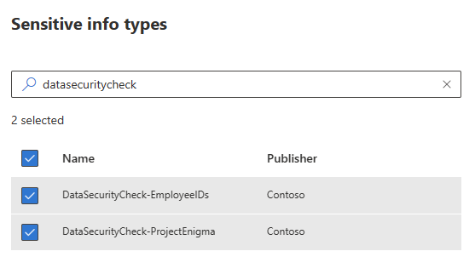

Note
Update the Out-of-box Sensitive Info Types to your customer’s requirements.

- Click Add.
- On the Create rule page, below Actions, click on Add an action.
- From the dropdown menu, select Audit or restrict activities on devices.
- Below File activities for all apps, select Apply restrictions to specific activity.
- Enable Copy to clipboard and verify the action is set to Audit only.
- Enable Copy to removable USB device and verify the action is set to Audit only.
- Enable Copy to a network drive and verify the action is set to Audit only.
- Enable Print and verify the action is set to Audit only.
- Enable Copy or move using RDP and verify the action is set to Audit only.
 Important
Carefully check and verify if all actions are configured correctly. Failure to do so will impact the user experience.

- On the Create rule page, below User notifications, below Use notifications to inform…., set the switch to Off.
- On the Create rule pane, below Incident Reports, below Send an alert to admins when a rule match occurs, set the switch to Off.
- Leave all other settings to default.
- Click Save.
- On the Customize advanced DLP rules page, Click Next.
- On the Test or turn on the policy pane select Turn the policy on immediately.
Note
It can take up to one hour for the new policy to go into effect.

- Click Next.
- Review your settings and then click Submit.
- On the New policy created page, click Done.

Next step
- Return to the <00-Master Delivery Guide> and continue the guidance provided in Step 3 - Setup and configuration.

Step 4 - Analyze the findings
In Step 4 of the Data Security Check the partner will, together with the customer’s tenant / Compliance Administrator, analyze all logs, information, and reports generated by the different Data Security Check tools and services. This section describes the additional steps required to prepare and analyze the results from the Data Loss Prevention for Endpoints activity.
It is recommended to do a two-step analysis of the log files, reports, and findings:
- Quick scan. By using the various dashboards and preview views you will be able to identify common patterns and/or trends that need further investigation and can serve as an example of privacy and regulatory risks. Look for “most impactful” events related to important people within the organization, high volumes of documents related to a specific business process, Personally Identifiable Information (PII), etc.
- Detailed analysis. Using exported log and report files for the various services will allow for further investigation of previously identified privacy and regulatory risks and events flagged during the quick scan. Aim at determining the impact and risk and consider possible solutions for mitigation. During this detailed analysis you are advised to leverage the insights of the customer team because they will know what and who to look for. To rule out “false positives” you are advised to do further investigation of all the events that will be included in the final close-out presentation at the end of the engagement.

Guidance
Activity Explorer, part of the Know your Data feature set, provides near-real time insight into activities on devices that are onboarded to Data Loss Prevention for Endpoints.

Objective
- Using Activity Explorer, create screenshots and identify risky behavior related to sensitive information on Windows 11 endpoints.
- Use Activity Explorer to identify whether there are data points which require further investigation in Data Loss Prevention or eDiscovery Search reports.

Background reading
- Get started with Activity Explorer

Pre-requisites
Prior to starting the activities in this step, the following mandatory Data Security Check activities as described in <00-Master Delivery Guide> should be completed:
- Step 1 - Kick-off meeting
- Step 2 - Acquire and assign licenses
- Step 3 - Setup and configuration
- Step 4 - Analyze the findings

Instructions – High level visualization
- On the local workstation, if not already done, extend the previously created directory structure by creating the \DataSecurityCheck\EndpointDLP folder.
- Browse to the Microsoft Purview portal at https://purview.microsoft.com/ and log in with Tenant Admin credentials or a user account that is a member of your Data Security Check team and has been assigned the appropriate permissions.
- In the navigation bar on the left side, click on Solutions.
- In the Solutions navigator, click on Information Protection.
- On the Information Protection solution card, expand Explorers.
- Below Explorers, click on Activity explorer.
- On the Activity Explorer page, next to Select filter set click on None .
- From the Dropdown menu, select Endpoint DLP activities.
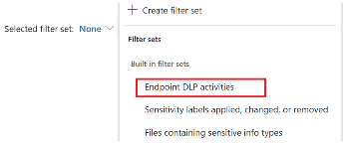
- Click on the Date filter and change the Start date to the beginning of the Data Security Check Automated Discovery, change the End date to today.
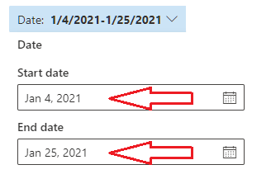
Note
The Activity Explorer consolidates findings from multiple sources in the Data Visualization graph. Please note that filtering on <Endpoint devices> will also include results from, for example, on-premises Automated Discovery using the Microsoft Purview Information Protection scanner. To further refine, use additional filters such as <Application> to exclude the Purview Information Protection scanner as shown in the illustration below.
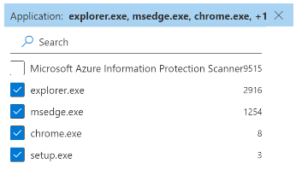

Important
At time of writing this document, the Application filter in Activity Explorer does not correctly lists the entry for the Microsoft Purview Information Protection Scanner, and this currently is an unresolved service-side issue. The change stems from an internal schema update that consolidated telemetry from endpoint DLP, service DLP, and on-premises Information Protection Scanners into a unified signal pipeline within Microsoft Purview.
As a workaround, it is recommended to use the <Device> and <Location> filters to create a dataset that excludes data discovered by the MIP Scanner. Set the <Location> filter to only include “Endpoint devices” and the <Device> filter to exclude the scanner’s server name (e.g., SCAN-01), additionally make sure all devices that have Data Loss Prevention for Endpoints enabled are included in the filter.
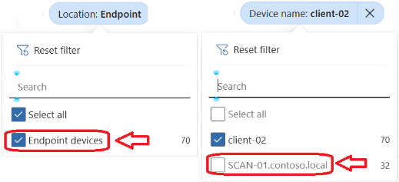

- Create a screenshot of the Data visualization.
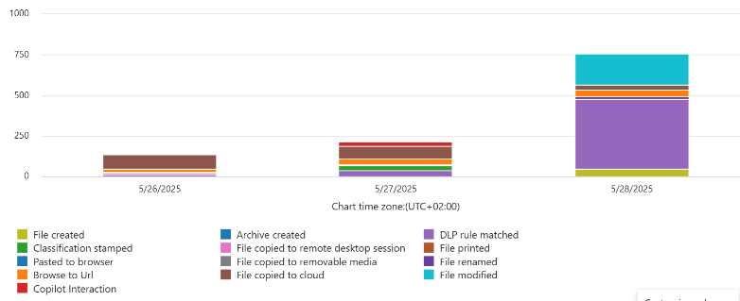

Note
Refer to Use Snipping Tool to capture screenshots for guidance on taking screenshots.

- Save the screenshot as <EndpointDLP – ActivityVisualization.jpg> to the previously created \DataSecurityCheck\EndpointDLP folder for future use in the close-out presentation.

Instructions – Detailed analysis
Note
The Activity Explorer export file will only contain fields that are visible at the time of export. To add additional fields use Customize columns.

- On the Activity explorer page, click Customize columns and at a minimum select:
  - Activity
  - File
  - Location
  - User
  - Happened
  - Sensitive Info Type
  - Sensitive Info Type Count
  - Application
  - Device name
- Click Export button to export the Activity log to a csv file.
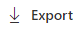
- Copy the Activity explorer _ Microsoft Purview.csv file to the previously created \DataSecurityCheck\EndpointDLP folder.
- Import Activity explorer _ Microsoft Purview.csv into Excel following the instructions in Appendix A – Formatting CSV files in Excel in the 00-Master Delivery Guide.
- In Excel, create pivot tables to provide insight into user behavior related to sensitive information.

Note
Use the examples below as a starting point and apply further customization to align with the specific customer findings.

- Overview of discovered Sensitive Info Types
Sample illustration  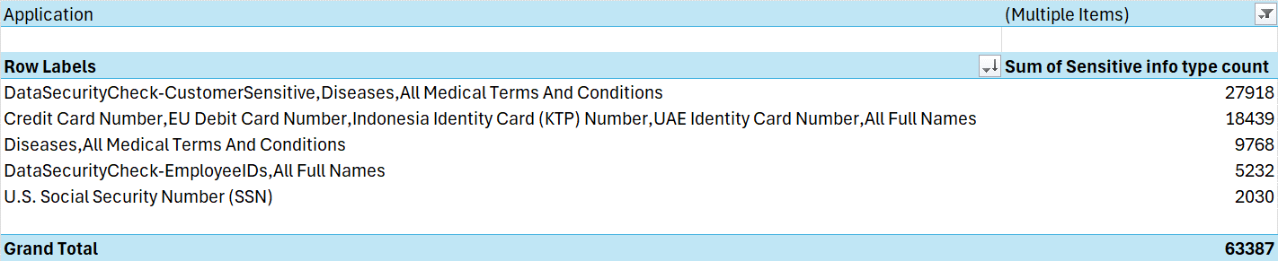 | 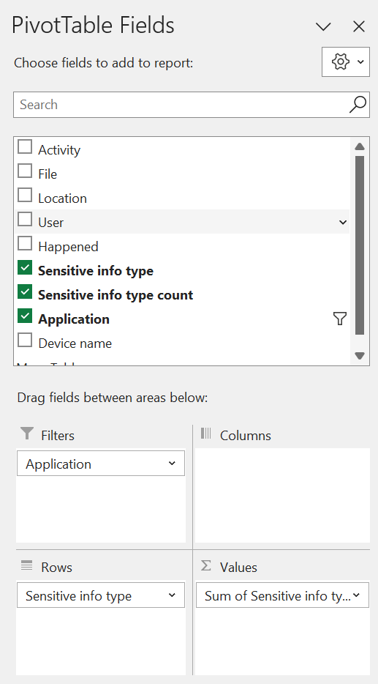 | Filters:  Application (if needed exclude Microsoft Purview Information Protection Scanner)  Columns:  Empty  Rows:  Sensitive Info Type  Ʃ Values:  Sum of Sensitive info type count  Sort:  Descending (Z to A) by Sum of Sensitive info type count.
- Activity related to sensitive information
Sample illustration  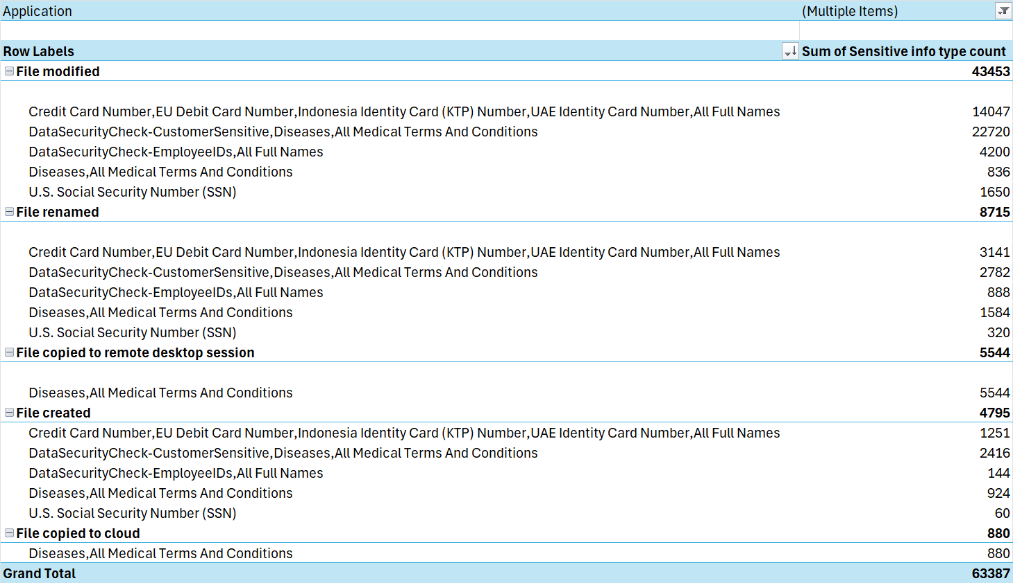 | 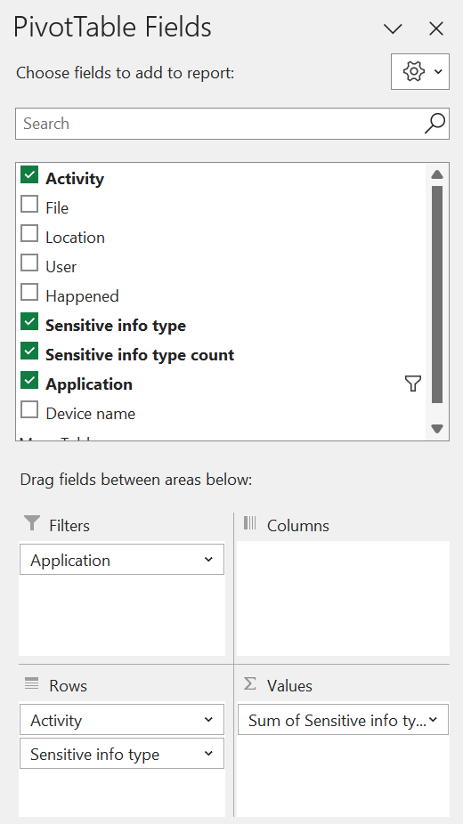 | Filters:  Application (if needed exclude Microsoft Purview Information Protection Scanner)  Columns:  Empty  Rows:  Activity  Sensitive info type  Ʃ Values:  Sum of Sensitive info type count  Sort:  Descending (Z to A) by Sum of Sensitive info type count.
- User activity related to sensitive information - 1
Sample illustration  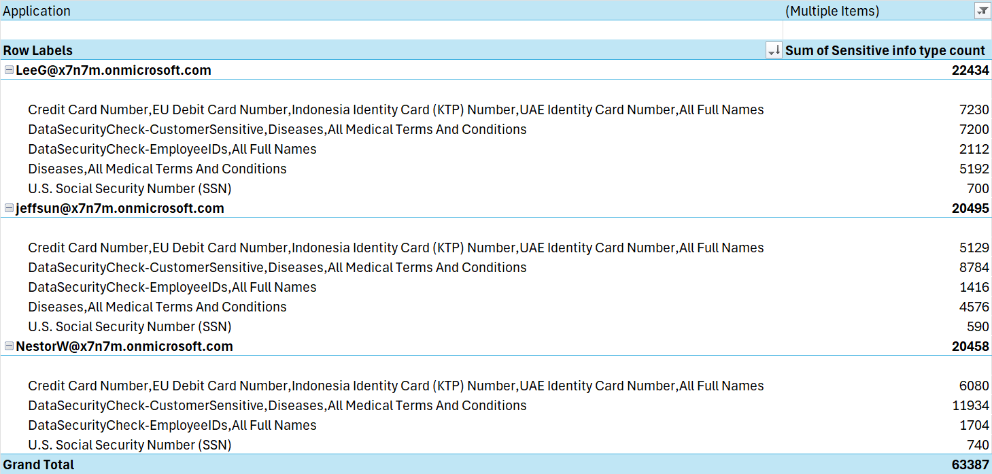 | 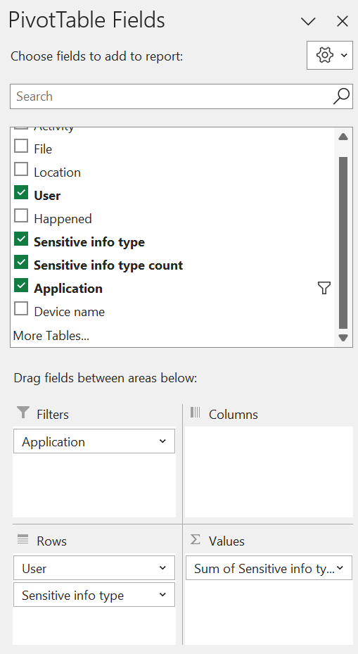 | Filters:  Application (if needed exclude Microsoft Purview Information Protection Scanner)  Columns:  Empty  Rows:  User  Sensitive info type  Ʃ Values:  Sum of Sensitive info type count  Sort:  Descending (Z to A) by Sum of Sensitive info type count.
- User activity related to sensitive information – 2
Sample illustration  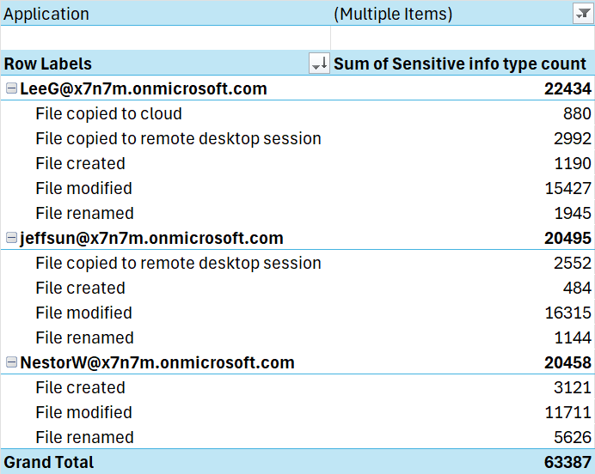 | 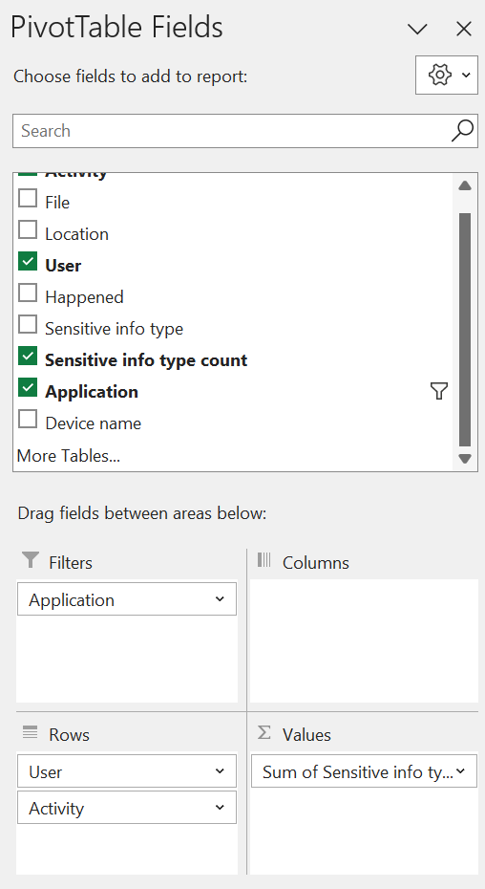 | Filters:  Application (if needed exclude Microsoft Purview Information Protection Scanner)  Columns:  Empty  Rows:  User  Activity  Ʃ Values:  Sum of Sensitive info type count  Sort:  Descending (Z to A) by Sum of Sensitive info type count.
- Save the updated Excel file to the previously created \DataSecurityCheck\EndpointDLP folder.
- When creating the close-out presentation, copy the pivot table to the appropriate slide(s) in the deck.

Next step
- Return to the <00-Master Delivery Guide> and continue the guidance provided in Step 4 - Analyze the findings.

Step 6 - Decommission

Guidance
The final activity for the Data Loss Prevention for Endpoints activity is to decommission the services and tools used for this activity.
Important
Do not perform the decommissioning steps, if the customer chooses to do so, until after the Proof of Execution (POE) has been filled out. The POE requires that evidence of the configuration is captured and will not be able to be completed if all of the policies are removed.

Objectives
The objectives for this activity are:
- Decommission the services that were installed to support the Data Loss Prevention for Endpoints.
- Offboard all endpoints that were manually onboarded to the Data Loss Prevention for Endpoints service.

Deliverables
For this activity, the following deliverables have been defined:
- All tools and services used during the Data Loss Prevention for Endpoints activity are decommissioned.
- All custom configuration artifacts are removed from the customer’s tenant.
- All manually onboarded endpoints are offboarded from the service.

Instructions – Turn off device monitoring
- Browse to the Microsoft Purview portal at https://purview.microsoft.com/ and log in with Tenant Admin credentials or a user account that is a member of your Data Security Check team and has been assigned the appropriate permissions.
- In the navigation bar on the left side, click on Settings.
- On the Settings card, expand Device onboarding.
- On the Settings card, below Device onboarding, click on Devices.
- On the Devices page, click on Turn off device monitoring.
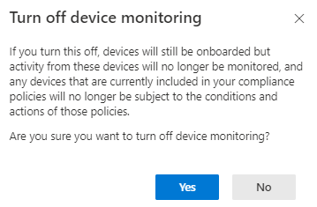
- Click Yes.

Instructions – Offboard endpoints
- Browse to the Microsoft Purview portal at https://purview.microsoft.com/ and log in with Tenant Admin credentials or a user account that is a member of your Data Security Check team and has been assigned the appropriate permissions.
- In the navigation bar on the left side, click on Settings.
- In the Settings navigator, expand Device onboarding
- Below Device onboarding click on Offboarding.
- On the Offboarding page, below Select operating system to start onboarding process, select Windows 10.
- Below Deployment method, select Local script (for up to 10 machines).

- Click on Download package. This will download the package as a zip file (DeviceComplianceOffboardingPackage_valid_until_YYYY-MM-DD.zip) to the default download folder.
- Copy the DeviceComplianceOffboardingPackage_valid_until_YYYY-MM-DD.zip file to the client workstation that has to be offboarded.
- Extract the contents of the configuration package (DeviceComplianceOffboardingScript_valid_until_YYYY-MM-DD.cmd) to a location on the device that needs to be offboarded.
- Go to Start and type Cmd.
- Right-click Command prompt and select Run as Administrator.
- Browse to the location of the script file.Activity Explorer
- Run DeviceComplianceLocalOnboardingScript_valid_until_YYYY-MM-DD.cmd.
- Verify the script completed successfully.
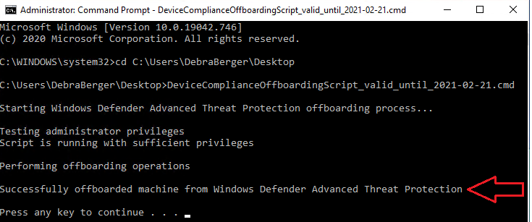
- Close the command prompt.

Note
For additional information on offboarding devices refer to Offboard devices from the Microsoft Defender for Endpoint service.

Instructions – Delete custom Data Loss Prevention policies
- Browse to the Microsoft Purview portal at https://purview.microsoft.com/ and log in with Tenant Admin credentials or a user account that is a member of your Data Security Check team and has been assigned the appropriate permissions.
- In the navigation bar on the left side, click on Solutions
- In the Solutions navigator, click on Data loss prevention.
- On the Data Loss Prevention solution card, click on Policies.
- On the Policies page, select the DataSecurityCheck-DLP-Custom-Devices policy.
- Click on Delete.
- On the DLP Policy pop-up, click on Delete policy.
- Click on Yes.

Next step
- Return to the <00-Master Delivery Guide> and continue the guidance provided in Step 6 - Decommission.

